MAWLANA BHASHANI SCIENCE AND TECHNOLOGY UNIVERSITY
SANTOSH, TANGAIL-1902



DEPARTMENT OF INFORMATION AND COMMUNICATION TECHNOLOGY
Lab Report

Lab Report No : 04
Lab Report on : Hands on practice of Grid CSS and Navbar CSS with minimum 2 Examples
Course Title : Web Application Development Lab
Course Code : ICT-3204

Submitted By | Submitted To
Name: Kuldip Saha Mugdha  ID: IT-22018  3rd Year, 2nd Semester  Session: 2021-2022  Dept. of ICT, MBSTU | Mr. Md. Anowar Kabir  Lecturer  DEPARTMENT OF INFORMATION AND COMMUNICATION TECHNOLOGY  MAWLANA BHASHANI SCIENCE AND TECHNOLOGY UNIVERSITY

Date of Performance: 15/11/25 Date of Submission: 28/11/25
Introduction:
CSS Grid is a powerful layout system that allows web developers to create complex and flexible web layouts using rows and columns.
A Navbar (Navigation Bar) is a critical web component that enables users to navigate between different sections of a website efficiently. Understanding the integration of Grid CSS with Navbar CSS improves both usability and aesthetics of web pages.
Objectives:
The aim of this lab is to get hands-on experience with CSS Grid and CSS Navbar. After this lab, students should be able to:
- Build structured page layouts using CSS Grid.
- Create vertical or horizontal navigation bars with working links and hover effects.
- Combine layout and navigation to make simple, user-friendly web pages.
- Improve practical skills in web design and page structuring.
This lab helps in understanding how to make web pages both organized and easy to navigate.

Tools Used:
- Editor: VS Code
- Browser: Microsoft Edge
- Languages: HTML5, CSS3

Part 1: CSS Grid Layout:
Example-1:
Code: index.html
<!DOCTYPE html>
<html lang="en">
<head>
<meta charset="UTF-8">
<meta name="viewport" content="width=device-width, initial-scale=1.0">
<title>Grid Challange</title>
<link rel="stylesheet" href="style3.css">
</head>
<body>
<section>
<div id="id1"></div>
<div id="id2"></div>
<div id="id3"></div>
<div id="id4"></div>
<div id="id5"></div>
<div id="id6"></div>
<div id="id7"></div>
<div id="id8"></div>
<div id="id9"></div>
</section>
</body>
</html>

style.css:
*{
margin: 0;
padding: 0;
box-sizing: border-box;
}
section{
display: grid;
grid-template-columns: 1fr 1fr 1fr 1fr 1fr;
grid-template-rows: 1fr 1fr 1fr 1fr;
grid-template-areas:
"id1 id2 id2 id3 id3"
"id1 id4 id5 id5 id6"
"id7 id4 id5 id5 id6"
"id7 id8 id8 id9 id6";
padding: 10px;
height: 100vh;
}
#id1{
grid-area: id1;
background: rgb(56, 20, 20);
border: 15px solid black;
}
#id2{
grid-area: id2;
background: green;
border: 15px solid black;
}
#id3{
grid-area: id3;
background: blue;
border: 15px solid black;
}
#id4{
grid-area: id4;
background: yellow;
border: 15px solid black;
}
#id5{
grid-area: id5;
background: purple;
border: 15px solid black;
}
#id6{
grid-area: id6;
background: orange;
border: 15px solid black;
}
#id7{
grid-area: id7;
background: pink;
border: 15px solid black;
}
#id8{
grid-area: id8;
background: brown;
border: 15px solid black;
}
#id9{
grid-area: id9;
background: gray;
border: 15px solid black;
}

Output:
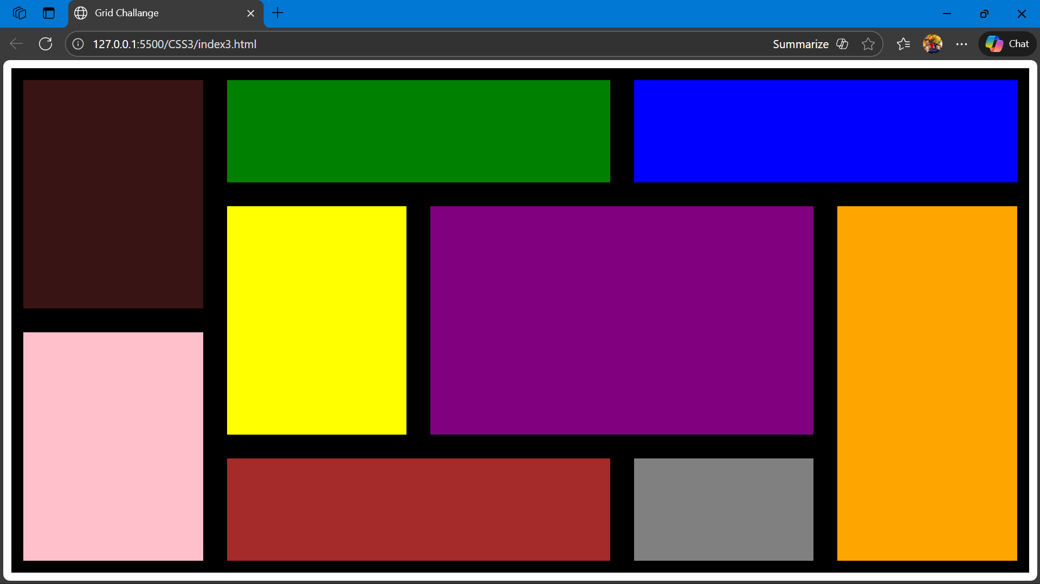

Example-2:
Code: index1.html
<!DOCTYPE html>
<html lang="en">
<head>
<meta charset="UTF-8">
<meta name="viewport" content="width=device-width, initial-scale=1.0">
<title>Grid Challange</title>
<link rel="stylesheet" href="style3.css">
</head>
<body>
<section>
<div id="id1"></div>
<div id="id2"></div>
<div id="id3"></div>
<div id="id4"></div>
<div id="id5"></div>
</section>
</body>
</html>

style1.css:
*{
margin: 0;
padding: 0;
box-sizing: border-box;
}
section{
display: grid;
grid-template-columns: 2fr 1fr 2fr 1fr;
grid-template-rows: 3fr 1fr 2fr 1fr;
grid-template-areas:
"id1 id2 id3 id3"
"id1 id4 id3 id3"
"id5 id4 id6 id6"
"id5 id4 id6 id6";
padding: 10px;
height: 100vh;
}
#id1{
grid-area: id1;
background: red;
border: 5px solid black;
}
#id2{
grid-area: id2;
background: green;
border: 5px solid black;
}
#id3{
grid-area: id3;
background: blue;
border: 5px solid black;
}
#id4{
grid-area: id4;
background: yellow;
border: 5px solid black;
}
#id5{
grid-area: id5;
background: purple;
border: 5px solid black;
}

Output:
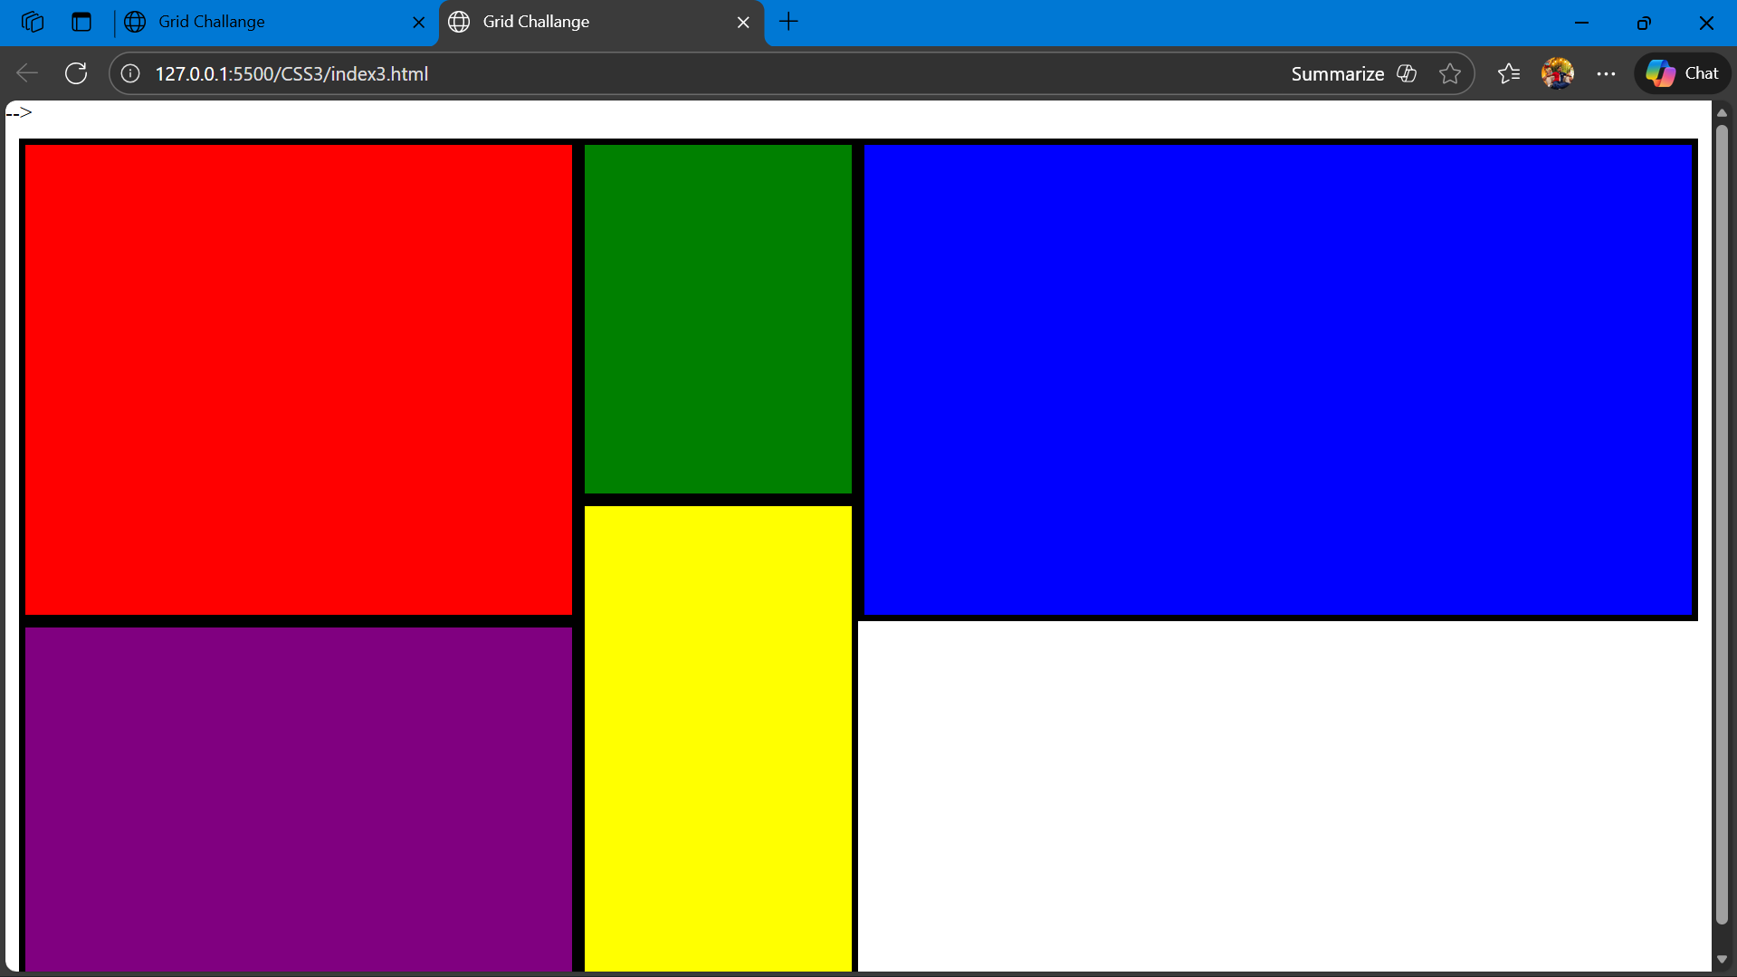

Part 2: CSS Navbar:
Example-1:
Code: index3.html
<!DOCTYPE html>
<html lang="en">
<head>
<meta charset="UTF-8">
<meta name="viewport" content="width=device-width, initial-scale=1.0">
<title>Nav Bar</title>
<link rel="stylesheet" href="style4.css">
</head>
<body>
<ul>
<li><a class="active" href="#home">Home</a></li>
<li><a href="#news">News</a></li>
<li><a href="contact.html">Contact</a></li>
<li><a href="#about">About</a></li>
</ul>
<div id="home">
<h1>Home</h1>
<p>Welcome to the Home Page!</p>
</div>
<div id="news">
<h1>News</h1>
<p>Lorem, ipsum dolor sit amet consectetur adipisicing elit. Molestiae dicta autem modi aspernatur expedita accusamus nam totam ab, dolorem quas. Dolore quae tempora deleniti explicabo nulla fugit molestiae libero aperiam nobis maxime quas at repellendus ut possimus necessitatibus voluptatem natus vel, nesciunt hic excepturi eius quisquam sit voluptatibus voluptatum. Tempora soluta, reiciendis odio, eius, aliquam dicta quibusdam eum alias quam quos libero similique consequatur nostrum voluptate eligendi. Quaerat sint deserunt, atque placeat nobis incidunt cum, exercitationem quos fugiat id porro maxime nulla inventore veniam libero quasi tempora aut dolore est dolorem? Similique atque consequuntur, commodi fugiat asperiores natus voluptate ex? ipsum dolor sit amet consectetur adipisicing elit. Laboriosam qui, neque fuga magnam molestias minima doloremque praesentium vel non! Error, velit iste ipsam dolore mollitia praesentium laudantium quibusdam soluta quae dolor nobis? Nihil debitis, est quas praesentium eligendi eveniet exercitationem deleniti id in, ratione laboriosam, porro labore. Culpa, iure cum!</p>
<div id="about">
<h1>About</h1>
<marquee>This is Kuldip</marquee>
</div>
</body>
</html>

style3.css:
body{
margin: 0;
padding : 10px;
}
ul {
margin: 0;
padding: 0;
display: flex;
list-style-type: none;
background-color: rgb(213, 46, 213);
}
ul li a {
display: block;
color: black;
text-align: center;
padding: 20px 50px;
text-decoration: none;
}
ul li a:hover {
background-color: lightgray;
}
ul li a.active {
background-color: rgb(234, 8, 8);
color: white;
}
ul li a.active:hover {
background-color: rgb(0, 0, 0);
}
Output:
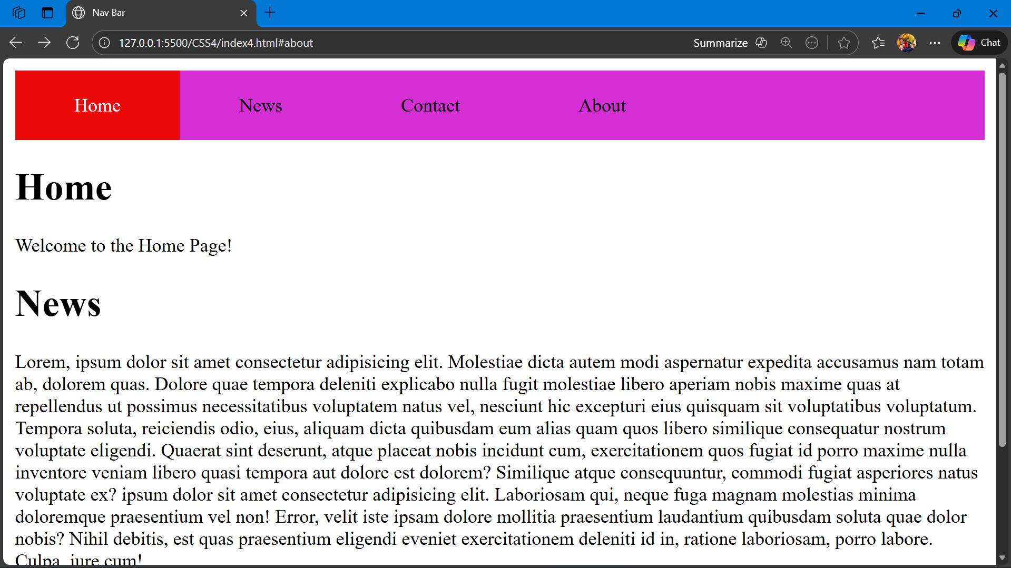
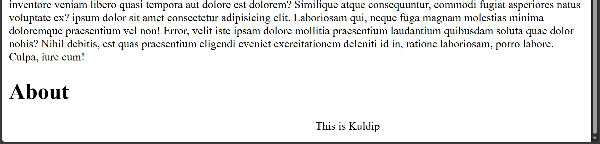
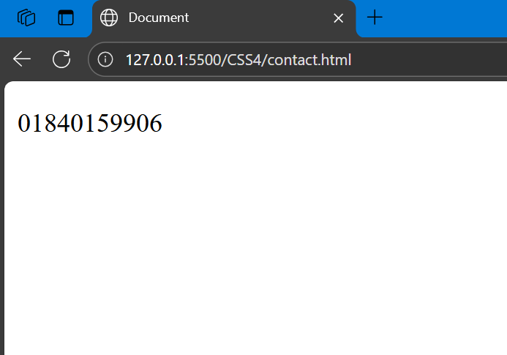
Example-2:
Code: index4.html
<!DOCTYPE html>
<html lang="en">
<head>
<meta charset="UTF-8">
<meta name="viewport" content="width=device-width, initial-scale=1.0">
<title>Navbar Example</title>
<link rel="stylesheet" href="style4.css">
</head>
<body>
<ul>
<li><a class="active" href="#home">Home</a></li>
<li><a href="#services">Services</a></li>
<li><a href="#products">Products</a></li>
<li><a href="#about">About</a></li>
</ul>

<h1 id="home">Home</h1>
<p>Welcome to the Mugdha67's home section</p>
<h1 id="services">Services</h1>
<p>Kono service dei na</p>
<h1 id="products">Products</h1>
<p>Ami bekar</p>
<h1 id="about">About</h1>
<p>Jibon techpata</p>
</body>
</html>
style4.css:
ul {
list-style: none;
margin: 0;
padding: 0;
background: rgb(0, 128, 255);
display: flex;
}
ul li a {
display: block;
color: white;
padding: 18px 40px;
text-decoration: none;
font-size: 18px;
}
ul li a:hover {
background: rgb(0, 100, 200);
}
ul li a.active {
background: rgb(255, 102, 0);
}
h1 {
margin-top: 40px;
padding: 10px;
}
p {
padding: 10px;
}

Output:
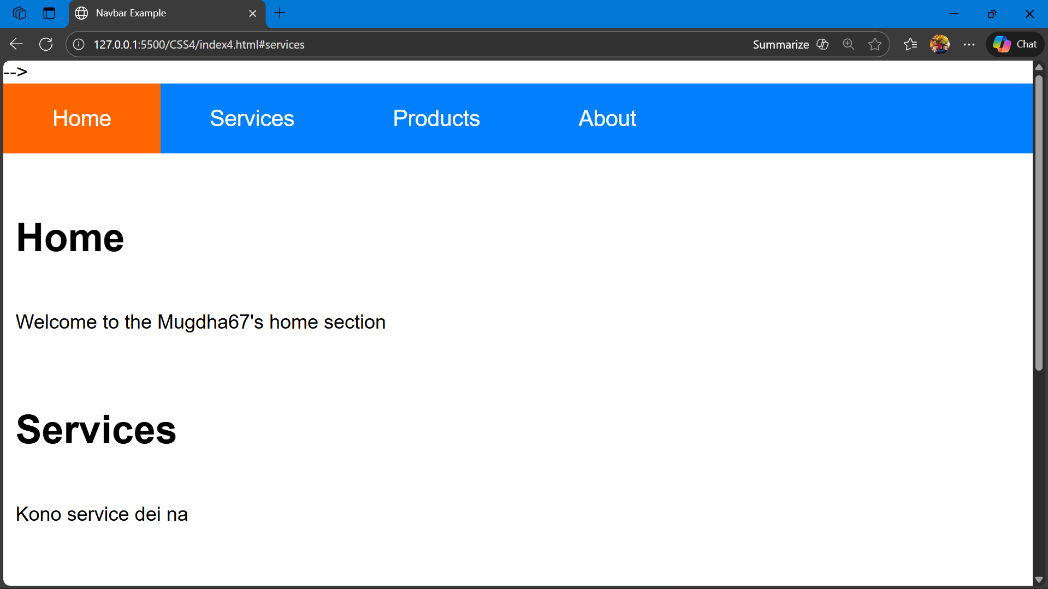
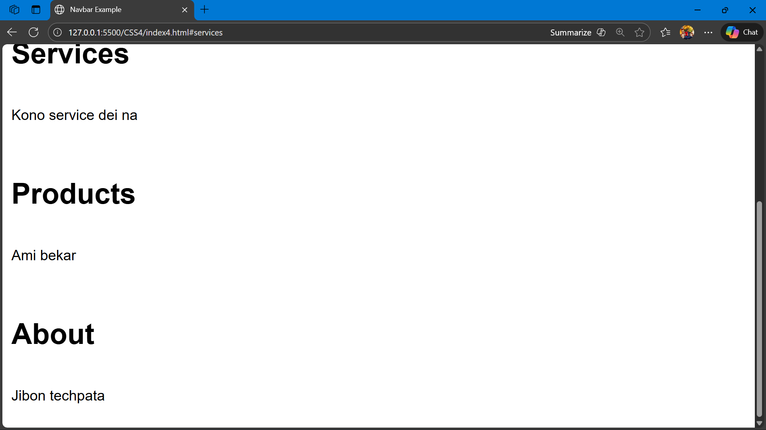
Result:
- CSS Grid provides a simple way to design multi-column layouts and control element placement.
- Vertical and horizontal navbars enhance website usability and navigation.
- Hover effects improve user interaction.
Conclusion:
Hands-on practice with CSS Grid and CSS Navbar improves both web layout skills and UI design efficiency. These experiments demonstrate how modern CSS techniques can create responsive, visually appealing, and functional web pages.

